Multimedia Project Proposal

Project Title: “HoloTrip”

­­­­­­­

By Aaron Meaney (14326016) and Wagner de Oliveira (14112621)

1st Year Multimedia Project Proposal

Project Idea

“HoloTrip” is a program that is downloaded to your Microsoft HoloLens running Windows 10. HoloLens is an augmented reality (AR) headset that creates interactive 3D holograms for the user, such as a working television that can be controlled through the built-in Kinect camera. “HoloTrip” will make full use of the HoloLens’ features to deliver a unique experience for the users.

When “HoloTrip” loads up, the user has an option to “Host” or “Join”. When the user selects “Host”, they open a private connection that allows other people to join. The user can then give their username to another person who could be in another country. The other user then selects “Join” and inserts the username into the text field. Once this happens, a connection is opened to the host’s HoloLens. During the setup process, the Host’s HoloLens begins to scan the environment around the user and compiles this data into a Hologram that the other user’s HoloLens displays. The other user’s HoloLens then displays the Host in Hologram form along with the environment. And the host can also see the other user in Hologram form. The users are rendered by collecting ambient data and reflections to display an accurate representation of how they look. If not enough data is available, then a generic human placeholder Hologram is presented. Multiple people can connect to one host at a time.

When the users are both connected, they are in “Scenic Mode”. This means that the host can freely walk anywhere, and the connecting user can see the environment dynamically render around them. This can allow people living in different places to interact more naturally with full body language and can really allow them to experience different cultures. This is the most immersive way to experience another country without actually physically travelling there.

“Game Mode” allows the connected users to play a variety of competitive and co-operative AR games. For example, the users can play a simulated holographic football match. The football will be rendered in 3D and can be played on a flat surface. The users can also set where the goals are and the play area. Of course, both users require the same area of flat space for a fair game.

If two users are physically beside each other and are using the “HoloTrip” app, then they can connect into each other’s space. This can allow multiple physical users to interact with multiple connected users at the same time. “HoloTrip” also has a “Background Mode” which allows the users to use other HoloLens apps in conjunction with the “HoloTrip” app. For example, a user can open a browser window and other users can see the same window open in 3D space, just like the user who opened it. This opens up many possibilities for collaboration.

How It Works

“HoloTrip” uses the built-in Kinect camera and sensor to detect 3D depth in the environment and uses this to build data that is sent to connected users. On the client’s side, the data is sent into the HPU (Holographic Processing Unit) to be rendered by the HoloLens. The environment is then displayed to the user and any hazards that they may physically walk into will be outlined. If the user begins to run or perform any action that may result in them hurting themselves, the environment is temporarily hidden so that the user can then look around their real environment. Once the user is ready, they can display the environment again. Also, if a user walks outside of a game session, then the environment is also hidden and an outline of the game area is displayed for the user to show them where they have to be

The user’s relative position to the host can be setup in three different ways: relative, fixed or first person. “Relative” position means that the user will stay in place if the host walks in a direction. If the host keeps walking in a direction and the user stays in one location, they will be repositioned beside the host because of memory limitations. In “Fixed” position, the user can still walk around like in “Relative” position, except the distance between the host and the client is always the same if the host begins walking and the user stays in place. This prevents the “rubber banding” effect from the previous position. And finally, “First-Person” position simply displays what the host sees from their point of view.

When the host looks towards far distances or large objects such as a mountain; the HPU will render faraway distances in two dimensions and display an artificial 3D effect to the 2D images in a similar fashion of a parallax barrier effect. This maintains the immersion that the connected user can see. The reason the HoloLens can’t render far distances is due the Kinect sensors’ range and the camera resolution.

When handling high-performance graphics and physics calculations, the HoloLens will usually be able to handle everything. If multiple players are playing a game that is physics dependant, then “HoloTrip” will automatically begin to render the graphics and calculate the physics from our dedicated NVidia GRID servers. Because all physics calculations within the app run on the NVidia PhysX API, the NVidia GRID will have native support for this processing, with minimal latency and high accuracy.

The HoloLens has the built-in ability to stream one user’s video feed and Holograms to another user. “HoloTrip” uses these software packages and expands upon them to deliver the experience that is only possible by using “HoloTrip”.

Target Market

The target market for “HoloTrip” are high-income adults with an interest in becoming more productive through the use of technology and/or are interested in seeing different parts of the world with their friends and also people with an interest in emergent technology. Another target market is corporations who wish to use technology to increase collaboration and production between employees.

A business could use a batch of HoloLens’ installed with “HoloTrip” to improve business meetings overseas. When a business meeting is held that implements “HoloTrip”, the meeting will be more personal as it feels like the attendees are really there. Because the attendees can communicate with full body language, it feels more natural and there is less of a communication gap between everyone. This can therefore help improve relations during the meeting. Also, because “HoloTrip” can display other apps within HoloLens, the attendees can open up word documents and spreadsheets to show at the meeting. The possibilities are endless and because of this, productivity is highly increased.

For single users, Peer-to-Peer collaboration overseas is also possible on project work. For projects on physical objects, such as 3D sculptures or machines, it is easier to evaluate the progress of a project when you are really there and are able to see it in 3D. “HoloTrip” makes this possible. People interested in seeing the world with other people can use “HoloTrip” to connect to a HoloLens set in another country, as described earlier.

Of course, people interested in the emergent technology of Holographic Computing can use “HoloTrip” as a means for profit. It could be a viable business choice for natives in different countries to set up “HoloTours”, where they sell tours to users with “HoloTrip” and then interact with their clients using the HoloLens. Other business opportunities are the concept of the “HoloHub”. A chatroom that exists in a real life location such as a landmark. The user would simply have to connect to a HoloHub to be able to interact with different people there. While at a HoloHub, different users can play games and recruit people for projects. Each HoloHub would be privately owned and could be paid for by advertisements.

“HoloTrip” will be sold as a downloadable program for your HoloLens set. The payment model will be a subscription fee every for unlimited use every Month, 6 Months or Year. Sold at €30, €50 and €100 respectively. A subscription model makes more sense than a one-time payment, as the user may not use this program all the time, and allows a more flexible payment plan for the user, as well as more profit for “HoloTrip”.

Marketing Campaign

The marketing campaign will consist of our website, a Facebook page and a Twitter page. The advertisement slogan is “Explore. Work. Play. Together”. This tagline reflects the main applications of using “HoloTrip” and then highlights the interaction between the host and the connected users.

The campaign will be split up into three phases. The goal of the first phase will be to create interest in the software in general. The Facebook and Twitter pages will both have images with cryptic messages on them which vaguely describe features to create interest in “HoloTrip”. This phase will last about a week, with a new image every day and a countdown to the next phase in each post. When the countdown reaches zero, the next phase will begin.

Phase Two will reveal the basic principles and features behind “HoloTrip”, as well as the logo and slogan. Now, information is drip-fed via images to further keep the consumers interested in the software. The images will be based on slogan “Explore. Work. Play. Together” slogan. There will also be another countdown towards the third phase of the marketing campaign.

The final phase will result in the launch of the “HoloTrip” website and will reveal that “HoloTrip” will have a launch-day release alongside the HoloLens. The price will also be revealed, and all posts will now link to the website. The website itself will now be the central medium for the campaign. The website will consist of six separate pages; “Home”, “Explore”, “Work”, “Play”, “Together” and “About Us”.

The home page will act as the landing page for the website and will display the most crucial information about the program. The main page will have sections that lead off into the main sections of “Explore”, “Work”, “Play” and “Together” sections. Each main section will advertise each aspect of the app, as well as have a demonstration animation for how it works. It will also be possible to share the website to Facebook and Twitter by clicking the appropriate buttons on the footer.

After the webpage is launched, there will be a few more periodic posts to the Facebook and Twitter pages, with each specific post linking off to one of the main sections on the website. For example, a post focusing on the “Explore” section will then have a link that sends the user to that specific section of the website. Just before the release of the app, a trailer will be released on Facebook and Twitter depicting the app being used. The trailer will also be hosted on YouTube which will reach more customers.

Similar Programs

Skype

Skype is a peer-to-peer messaging program owned by Microsoft. Skype can be used for conference calls and business meetings with up to 25 users. This service is free and works across multiple operating systems and platforms. At the moment, Skype allows standard video and text messaging in business calls, but a HoloLens Skype app will be available on launch. The main difference between Skype and “HoloTrip” is that Skype still renders the other user in 2D and only displays what the camera sees. Although you can share files with each other and share what you can see on your screen, you can’t allow multiple users to work on the same file, unlike “HoloTrip”.

“HoloTrip” also has extended functionality over Skype, such as the ability to play immersive games and to allow the users to walk around freely. Although Skype on mobile platforms do allow the users to walk around, there is still no 3D rendering of the environments. Skype has been advertised on websites owned by Microsoft and has been features in its own television advertisements. Skype has a well-developed reputation.

TeamViewer

TeamViewer is software that allows one user to control another user’s desktop using remote desktop connection. This means that multiple users can work on the same computer and files from different places. TeamViewer also supports a presentation and collaboration mode with support for up to 25 users, like Skype. Unlike Skype and “HoloTrip”, TeamViewer doesn’t allow the user to walk around freely and requires that the user stays at their computer as TeamViewer only works on desktop (and laptop) computers.

One limitation of TeamViewer is that only one person at a time can remote control the computer, so if you want to multitask on the same computer with multiple people, it is not possible. This is possible with “HoloTrip” though. One user can be working on a word document while another user is working on an excel spreadsheet. Both files are hosted on the same HoloLens and both users can run different programs if they desire. With “HoloTrip”, sending a file to another user is literally just grabbing the file from your folder and handing it over the other user. TeamViewer has its own website and is well-known software. It isn’t explicitly advertised but it can be found on other websites such as softonic.

Desktop Wireframes

Homepage Top

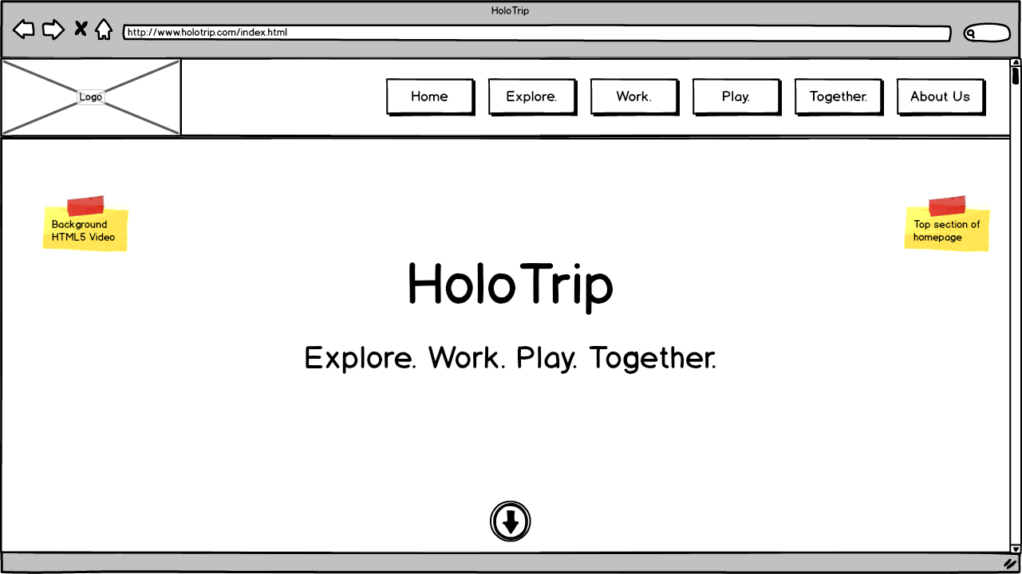

Homepage Section

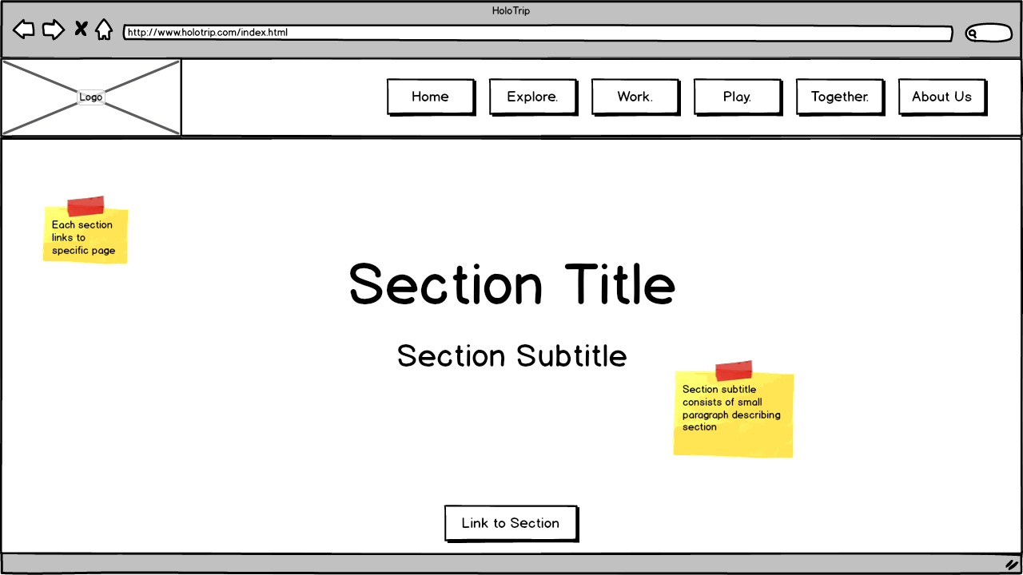

General Footer

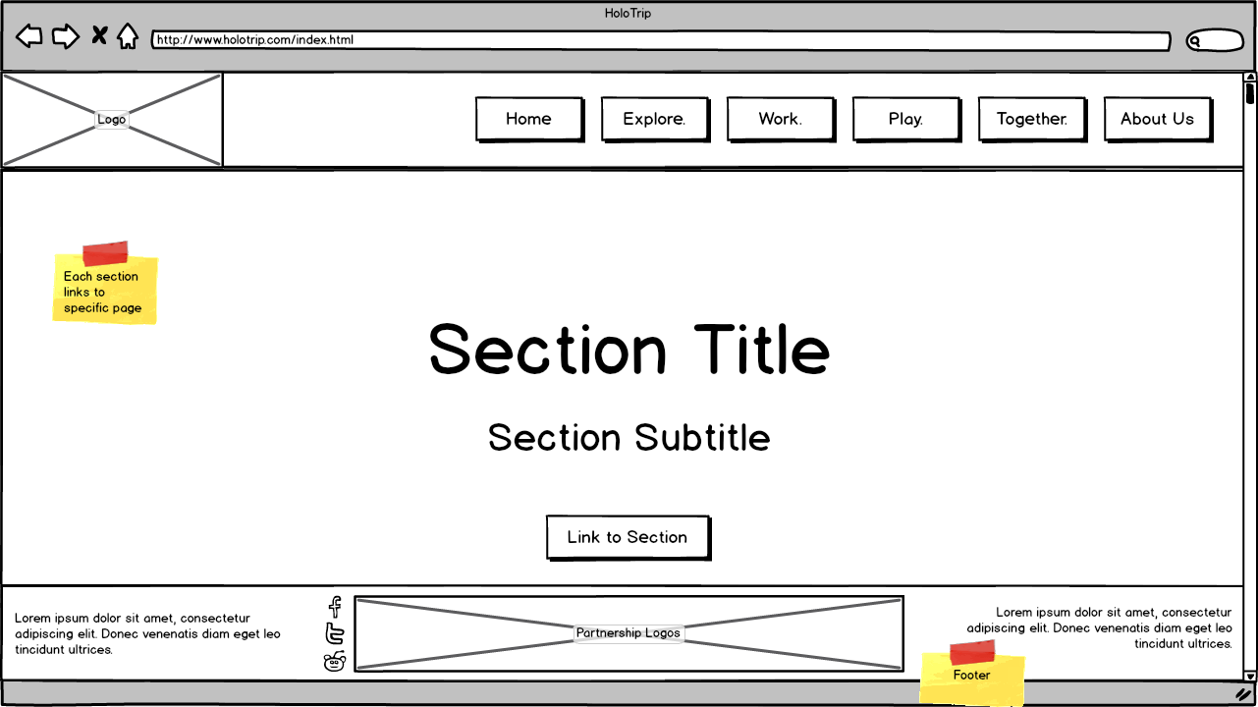

Image Section / Animation Section

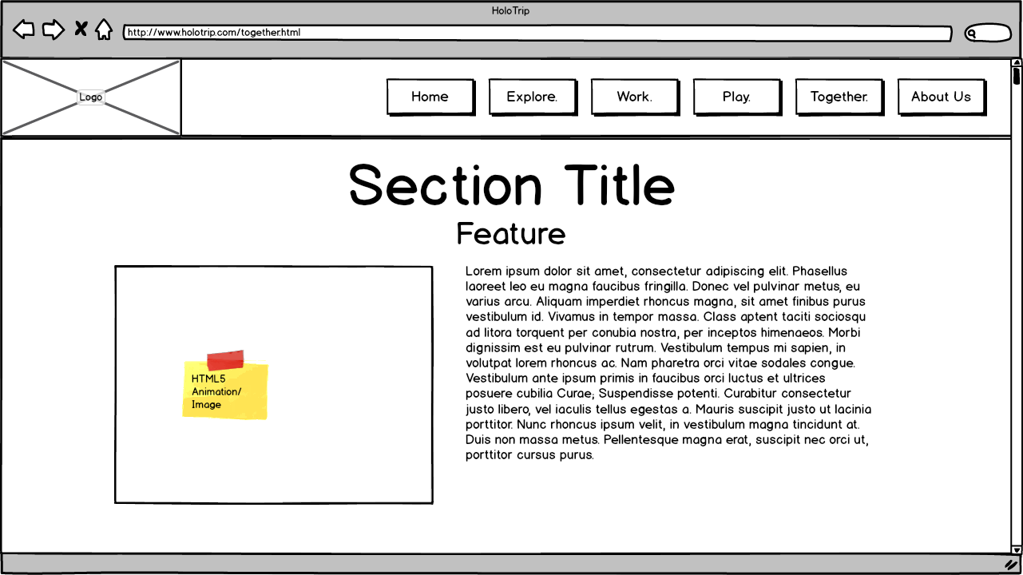

Text Section

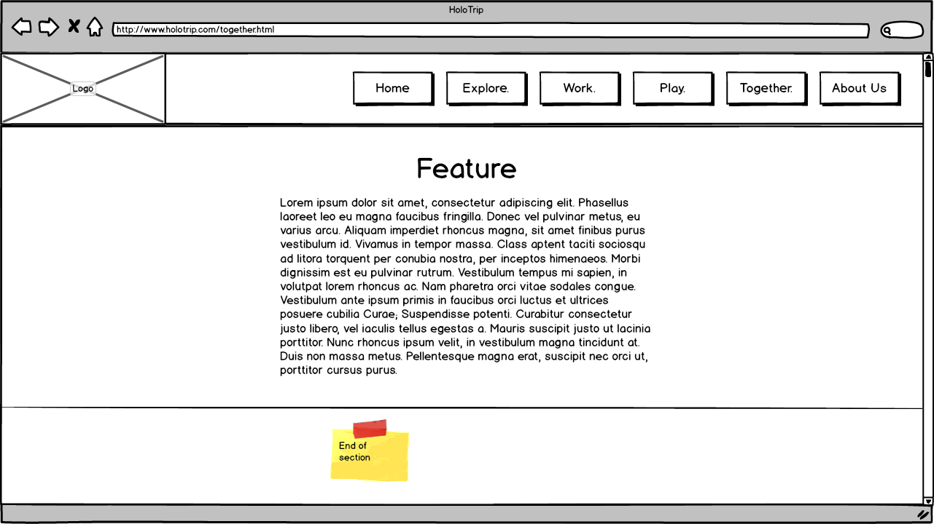

Mobile Wireframes

Homepage Top

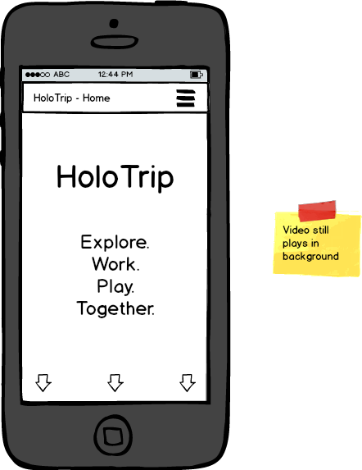

Homepage Section

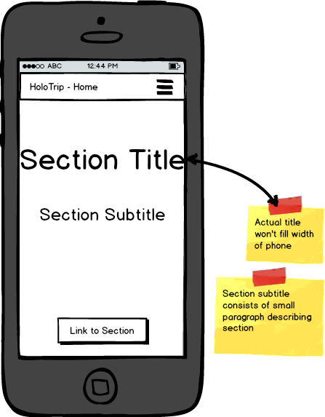

General Footer

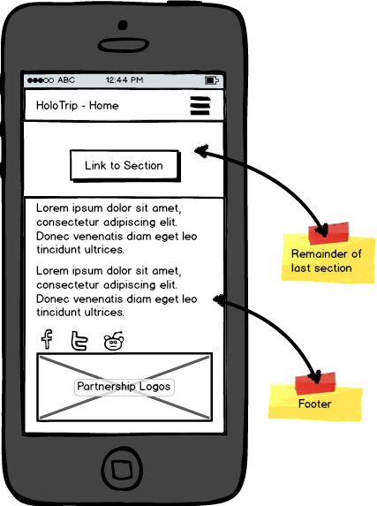

Image Section / Animation Section

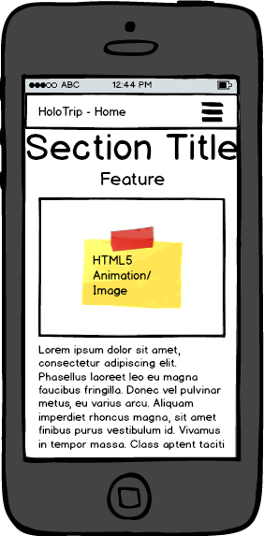

Text Section

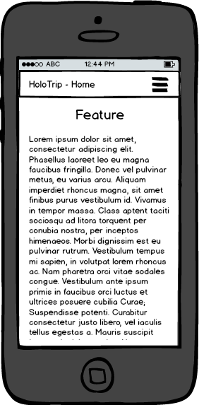

Animation Storyboard

Title: “What can you do with HoloTrip?”

This animation runs on the homepage to introduce the user to the main concept of HoloTrip.

